|  |  |
| --- | --- |
|  | ***Study*** |

Read chapter 13 of the following book:

Learning Python:

<http://www.dsf.unica.it/~fiore/LearningPython.pdf>

Then answer the quiz in page 414

|  |  |
| --- | --- |
|  | ***Serious exercises*** |

**Exercise 1**: Write a program to check whether a number is a prime number

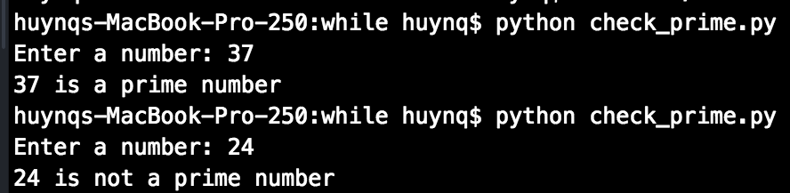

**Exercise 2**: Modify the username password in previous session to allow users login at maximum 3 times

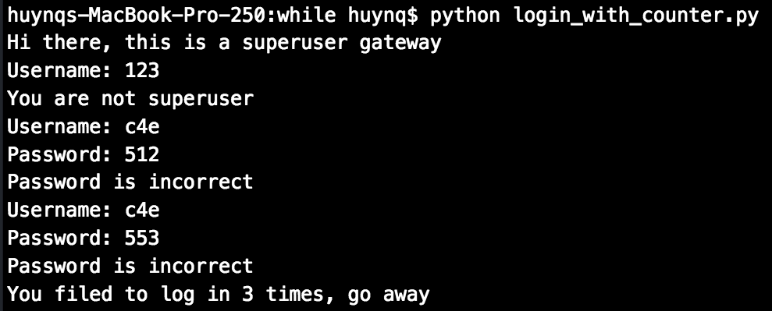

**Exercise 3 (Optional)**: Modify guess_my_number.py to the opposite scenario, you think of a number and then the program takes a guess, then you tell it where its guess is correct, smaller or larger than the number you’re thinking

